Moosle-Ee: Massive Open Online Social Learning Environment for English Elearning System

ABSTRACT
In language learning there is a need for collaborative and social learning. A kind of learning that gives the students the opportunity to work together online and use the foreign languages in real time. This article is to list the kinds of social and learning properties that we already have online. We will give a small review about a new idea MOOSLE (Massive Open Online Social Learning Environment), which uses the collaboration and social environment to build a platform for sharing courses and learning materials. MOOSLE opens a new way for collaboration and gives the users the power of sharing their work and courses and tracking it inside or outside of the system for free. They search for other courses, engage in new MOOCs (massive open online course), work in groups. We are trying to push the reusability to the extreme with MOOSLE, to use the common social properties in a structural collaboration way for learning.
КЛЮЧЕВЫЕ СЛОВА: English, collaboration, learning management system, student, MOOC, eLearning, MOOSLE.

introduction
Social networks are online administrations that enable people to build an open or semi-open proﬁle inside a limited framework, explain a rundown of different clients with who they share an association, view and navigate their rundown of associations and those made by others inside the framework. The nature and classification of these associations may change from site to site (Evriklea Dogoriti and Jenny Pange, Gregory S. 2014.). From an e-Learning researcher’s view we can say that social networks are a platform which has user management that allows discussions, collaborative work and learning, publishing experiences and thoughts, sharing information and resources. The expanded fame of informal organizations, for example, Facebook and Twitter have tremendous number of social clients. It gives the chance to get to more assets as far as learning and sharing (Huseyin Bicen, Saide Sadıkoglub, Gunay Sadıkoglu ,2015) and allows people to communicate, share memories, information and feelings. All these features attracted a huge amount of users reaching to 1.71 billion monthly active ones who were on Facebook in 2016 (Statista. 2016) and 1 billion users on YouTube (YouTube Stats: Site Has 1 Billion Active Users Each Month .2013), 317 million users on twitter (Statista .Number of monthly active Twitter users worldwide from 1st quarter 2010 to 3rd quarter 2016 (in millions) – URL: \\ https://www.statista.com/statistics/282087/number-of-monthly-active-twitter-users/), 500 million users on Instagram (Statista. Number of monthly active Instagram users from January 2013 to June 2016 (in millions) – URL: \\ https://www.statista.com/statistics/253577/number-of-monthly-active-instagram-users/), 450 million members on LinkedIn (Social media statistics – URL: \\ https://www.statista.com/statistics/274050/quarterly-numbers-of-linkedin-members/). Through those social networks people could establish their communication (Huseyin Bicen, Saide Sadıkoglub, Gunay Sadıkoglu ,2015), share their photos, videos, emotions, texts, educational subjects and learn from each other. In this paper we will list the properties of MOOCs and social networks to show effectiveness of a social collaboration platform.

methods
The current paper is focused on definitions to learning systems, their structures, advantages and characteristics used in learning English. There applied such methods of study as observation, testing, investigating and summarizing the experience of other researchers. The information approach has provided expeditious and high-quality implementation of feedback. The materials for this study were the researches of Evriklea Dogoriti and Jenny Pange, Gregory S. Anderson in their work
"The utilization of person to person communication and learning administration frameworks in English dialect instructing in advanced education" (Evriklea Dogoriti and Jenny Pange, Gregory S. 2014.), Huseyin Bicen, Saide Sadıkoglub, Gunay Sadıkoglu "The Effect of Informal communities on College Understudies Learning Outside Dialect" (Huseyin Bicen, Saide Sadıkoglub, Gunay Sadıkoglu ,2015). We likewise utilize the consequences of the exploration that was held by Nadire Cavus, Huseyin Uzunboylu, Dogan Ibrahim "Understudy sentiment towards utilizing an open source learning administration framework together with a synergistic device" (Nadire Cavus, Huseyin Uzunboylu, Dogan Ibrahim,2008).

Results
We will only speak about the social features of social networks considering that all those characteristics can be used in a collaboration and social learning environment.
We can say that a social website will have the main social system and other sub-systems. The sub-systems contain all the information about the users, materials and connections between them. We see that one of the sub-systems is a user management sub-system, which defines their profiles and the relationships between them. The profile allows people to express themselves and what is going on in their lives and choose what to share and with who. We can see CMSS (Content Management Sub-System) permits to upload files, photos and videos with setting the privileges of access.
Another important sub-system to control the pages, events and groups defines the relationship between them and the users. The users can share information, media files, experiences in their profiles and have the privileges to comment any material. Communications between the users are defined by the relationships between them in the main system. These relationships can be sharing, tagging and chatting with each other or with a group of people, doing conferences or life time videos (IEEE, “The Use of Tin Can API for Web Usage Mining in E-learning Applications on the Social Network”, Oct 15.2015, – URL: \\ http://ieeexplore.ieee.org/abstract/document/7298338/).
MOOC properties
MOOCs (Massive Open Online Courses) are courses intended for a substantial number of members. They can be gotten to by anybody anyplace as long as they have a web association. MOOCs are available to everybody without section capabilities and offer an entire course encounter online for nothing. The creator of MOOCs is Dave Cormier, when he published one course on the internet and 2000 students participated in that course in 2008 (Elearning industry “definition of a MOOC” – URL: \\ https://elearningindustry.com/the-definition-of-a-mooc). Monstrous Open Online Course is a reaction to the difficulties looked by associations and disseminated disciplines. People could get access to the information about a topic and the instructors analyzed journals and books to pull the information together from a library. They might have found others who were also interested in the same things. MOOC is one the ways of learning in a network world. MOOC is an open interactive course supporting lifelong network. It has materials, dates of beginning and finishing, participants themselves. It is a way to connect and collaborate while developing digital skills, to engage in the learning process where people can get together and work and talk about any topic. The course operates in the following ways:

● All the work is done in zones available for individuals to peruse, consider and remark.

● The clients can simply ahead and take the course without paying for it.

● The work done in the course is shared between every one of the general population taking it.

● The material is assembled by the facilitators.

The clients get the chance to keep their work in the framework and every other person gets the chance to gain from it in light of the fact that the course is participatory. The course is distributive and it posts the dialog of recordings, remarks to articles, tweets and labels. All these are connected together to make a system course and generally not found in one focal area everywhere throughout the web yet in various pockets and groups. There is no correct approach to do the course, no single way from the main week to the last. This enables new plans to create and diverse purposes of perspectives to exist together. It likewise implies that one of the symptoms of MOOC is the working of appropriated learning base on the net. MOOC advances freedom among students and urges members to work in their own particular spaces, to make valid systems that can keep up after the course wraps up. In the course instructive substance Video – Sound – Content – Amusements (incl. recreation) – Online networking – Activity might be incorporated. The course offers conceivable outcomes for perusers' association, for example, online networking channels, discussions, sites or RSS (Extremely Straightforward Syndication) to fabricate a learning group.

Members are given some input instrument. It can be consequently produced (e.g. tests) just by peers (peer criticism) and additionally broad input from scholarly staff. The course dependably gives some sort of acknowledgment like identifications and a testament of fruition. A formal authentication is discretionary and in all likelihood must be paid for. The course more often than not contains an investigation direct syllabus, which incorporates guidelines how understudies may gain from the exhibited materials and associations.

Discussion
Dialect is the technique for human correspondence, either talked or composed, comprising of the utilization of words in an organized and traditional way (IEEE, “E-Learning Standards and Learning Analytics”, March 13.2013, – URL: \\ http://ieeexplore.ieee.org/document/6530268/). We think that learning a language is a social thing because it is a social tool for face-to-face communicating with other people or texting. From this point we can understand that it will be a good practice to try teaching or learning languages in a social site with the help of other people in an open collaborative and structured way. All things considered, understudies have expressed that they have a constructive outcome of informal communication destinations on learning remote dialects .The examination demonstrated that Learning Administration Framework (LSM) can turn out to be more proficient on the off chance that it is improved by shared learning apparatuses . Suggestions are made in connection to the successful utilization of a long range interpersonal communication stage to help gainful and significant learning (Jie Lu, Daniel C. 2014). Understudies have said that they take after proposals of expert outside dialect educators and utilize different accessible offices keeping in mind the end goal to enhance their talking abilities .
In our opinion, one of the best ways to teach or study a language is by a social platform or an interactive course, which gives the students the feeling of working with someone else. We consider it is not enough to have a social network to start learning languages. The students can study but not with good results, because there is always a need for some structure that must be presented LMS courses. That means we need a social network and a structured course like MOOC. We definitely must track the students and if we cannot do it with MOOC. WHY? As we have already understood MOOC can be distributed. Therefore, if we really want to track our students, we must give an interface for communicating with our system from the outside. Inside the system we must allow the users to share lessons or learning materials, do a repository for all learning lessons and materials for others to use those assets. If we use the system like LRS, teachers can share the courses on their websites and have the opportunity to track their students in other LRS. We also can save this tracking information in our LRS in the same time.
4.1.MOOSLE Structure
In MOOSLE we started to think about socializing courses not only making collaborative courses. But we give the users the power to share courses online, to do their channels of the lessons in their own way, to put the content for free, to get a certificate for some money and to share the materials in the repository which holds all the learning content of our social learning environment.
All the users can share their content in their profiles, or in groups for collaboration work, or in MOOC. The access privilege can be for a group of users or public.
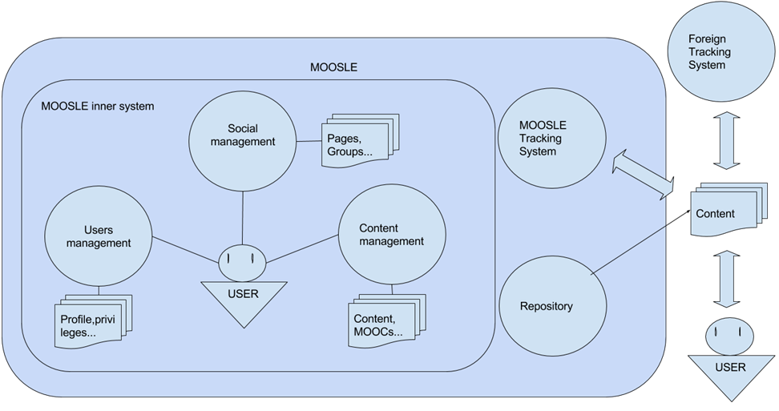
Figure (1) The structure of MOOSLE

In both ways the content will be available for everybody from the repository of the system. For every MOOC, lesson or learning asset there will be meta data in the repository which informs who used it in our system. This meta data helps the users to access the historical information of the learning material for reading.
There are a lot of structures inside the environment for people, schools or universities.
For every user there will be a profile, where they can put and share all their personal information and academic knowledge, have friends, share photos, videos, albums, music and lessons.
The users can participate in MOOCs, be a part of a group, an event, a discussion, or reuse any material inside or outside the system. MOOCs stand alone, and the users enroll in them with or without collaboration. MOOCs have assignments, discussions and learning materials in the system. Being a group member gives the privilege access to MOOCs inside them without registration, and all the students in the group are tracked together. Students’ results have a hierarchy in the system to help teachers to control their work. However, we are not saying that this MOOC is for a particular school or group. When MOOC is a part of a group, it gives the users of this group the privilege to participate in private discussion, which can be accessed to other groups only for reading. MOOC has an open discussion for public users.
In MOOSLE we use the same technique as LRS in a matter of saving all the users’ data online or offline and from different platforms.
We save offline data because using something like LRS gives the opportunity for the users to work offline where there is no secure internet. There are two reasons for the platforms. Firstly, MOOC functions on different platforms simultaneously. The second reason is the reusability of the course or content. When we work in a tracking system, the users must give the system URL or web service to the materials (lessons, MOOCs, games, simulations) and the materials get access to the system. Therefore, we obtain the information about all the users, which worked with this material all over the internet.

SUMMARY
Summarizing all the above we can conclude that MOOSLE gives the users the opportunity to do courses which are free. They collect information and provide feedback about their work. Using social networks, MOOCs and outside tracking systems help to track and visualize data depending on the groups of users, discussions and feedback.
MOOSLE uses a social network to connect people with each other and teachers with their students in a way of sharing and having fun in the same time.
MOOSLE offers the users to do MOOCs and give knowledge for free to more people than usual as a lot of people like to do it on YouTube but in more professional way.
MOOSLE allows the users to share and to get a big feedback with all the details that they need.
MOOSLE gives the users the opportunity to work with other courses from the system repository and to reuse it inside or outside the system.

conclusions
Using only LMS for teaching language is not enough in our time, and doing a non-structured social network for teaching English is not a good idea. In the end we confirm that using MOOCs in a social network does a big deal with English learning. For tracking the system needs an interface and this interface lets the users share materials inside and outside the system. These materials link to the system and can be tracked despite they are in the system or not. This kind of work is to do a social collaborative network for sharing learning materials in a good and structured way to make professional and free learning.

БЛАГОДАРНОСТЬ (acknowledgements)
The work is performed according to the Russian Government Program of Competitive Growth of Kazan Federal University.
The authors wish to express their sincere thanks to Ammar Kherbek and Mohammad Hameed for their invaluable assistance.
- Bibliography
Evriklea Dogoriti and Jenny Pange, Gregory S. Anderson The utilization of long range informal communication and learning administration frameworks in English dialect instructing in advanced education/Grounds Wide Data Frameworks Vol. 31 No. 4, pp. 254-263, 2014.

Elearning industry "meaning of a MOOC" – URL: \\ https://elearningindustry.com/the-meaning of-a-mooc

IEEE, "The Utilization of Tin Would api be able to for Web Use Mining in E-learning Applications on the Informal community", Oct 15.2015, – URL: \\ http://ieeexplore.ieee.org/unique/report/7298338/

IEEE, "E-Learning Benchmarks and Learning Investigation", Walk 13.2013, – URL: \\ http://ieeexplore.ieee.org/report/6530268/

Jie Lu, Daniel C. The eﬀect of social collaboration on learning engagement in a long range informal communication condition/Intuitive Learning Situations, Vol. 22, No. 4, pp.401 – 417, 2014.

Nadire Cavus, Huseyin Uzunboylu, Dogan Ibrahim Understudy conclusion towards utilizing an open source learning administration framework together with a synergistic device/Cypriot Diary of Instructive Sciences, Vol 3, No 2, pp.120-129, 2008.

Huseyin Bicen, Saide Sadıkoglub, Gunay Sadıkoglu The Effect of Interpersonal organizations on College Understudies Learning Remote Dialect/Elsvier Ltd. Procedia - Social and Behavioral Sciences 186, pp.1045 – 1049, 2015.

Statista. Number of month to month dynamic Facebook clients worldwide starting at third quarter 2016 (in millions) – URL: \\ http:/www.statista.com/measurements/264810/number-of-month to month dynamic facebook-clients around the world/

Statista .Number of month to month dynamic Twitter clients worldwide from first quarter 2010 to third quarter 2016 (in millions) – URL: \\ https://www.statista.com/insights/282087/number-of-month to month dynamic twitter-clients/

Statista. Number of month to month dynamic Instagram clients from January 2013 to June 2016 (in millions) – URL: \\ https://www.statista.com/insights/253577/number-of-month to month dynamic instagram-clients/

Online networking measurements – URL: \\ https://www.statista.com/insights/274050/quarterly-quantities of-linkedin-individuals/

YouTube Details: Site Has 1 Billion Dynamic Clients Every Month – URL: \\ http://www.huffingtonpost.com/2013/03/21/youtube-stats_n_2922543.html.

