The «Rank-Size» Model As A Tool To Assess And Forecast Sustainable Development Of The System Of Cities In A Region

Autores

Margarita D. Mironova. Kazan Federal University ,marg.mironova2011@yandex.ru
Pang Te. Kazan Federal University

Fecha de recibido: 2019-09-13
Fecha de aceptado para publicación: 2019-09-18
Fecha de publicación: 2019-09-30

Abstract
The article deals with the most serious problems of formation and development of the system of cities in the territory of the Russian Federation. The analysis of dynamic changes of city systems using the law "rank-size"is carried out. The author comes to the conclusion that the specific failure of the policy of urban alignment in formulating strategies for economic development of regions in the second half of the twentieth century indicates the need for large-scale approaches to solving the problem of balanced growth of urban systems that ensure sustainable economic development of regions and the country as a whole.
Key words: rank-size, policy of urban alignment, large-scale approaches
Introduction
The urbanization process, which was at its highest in the twentieth century, has resulted in giant megacities emerging. Their territorial and functional structure can be represented as a “tree” graph.
A large agglomeration city rapidly growing much like the shape of a star evolves drawing smaller cities and towns located in its catchment area into the rhythm of its life. However, large areas of such territories located in between the rays remain unbuilt. The total area of the circular zone which is comprised of the urbanized territories and the open spaces dividing them is more often than not very large. The production capacities coupled with the population in this area also play a substantial part. In consequence, from the perspective of economic development and spatial structure, metropolises like this are in large part similar to a medium - sized region with an inherent complex system of functional links between the relatively isolated areas.
The most telling examples of such complex systems of metropolitan cities can be found among urbanized clusters of cities such as the multipolar megacities in the United States, the Tokyo - Yokohama system, etc. A city which is growing comes to unite more and more habitats. However, the average population density across this urbanized territory proves to be much lower than in individual areas usually located in the center of megacities. This can be attributed to the so-called uneven distribution of population across the area of agglomerations. The huge space of a city agglomeration offers a multi-level hierarchy of residential and industrial zones mixed with prosperous and stagnant neighborhoods, satellite cities and settlements of significantly varying economic development and welfare.
The peripheral environment drawn into the range of influence of a metropolis is in no way conducive to administrative unification. Another outcome is the conglomeration of external settlements which spring up around the city which typically feature cottages. Such buildings are usually located not too far from the central business part of the city, and usually close to a highway or a railway.
Researchers tend to point to a certain institutional weakness of the largest cities when assessing this pattern of urbanized territorial growth. Having said that, the existing decentralization of the central and peripheral areas of megacities has laid bare the legal difficulties associated with harmonizing the legal framework for the functioning of independent self - government entities which together make up a single economic system. The complex, polycentric administrative structure, resultant from developing metropolises at the same time represents a system in which strategic urban development challenges are very difficult to address. However, the diverse metropolitan areas different in their economic states are certain sustainable social entities within urban agglomerations. The substantial role of these areas in the process of harmonization of relations between different population groups within a metropolis in the established system of their certain territorial separation has been emphasized. Competition among such separate territorial units generally leads to improved efficiency of metropolitan management while also maintaining its integrity.
The Zipf's law on rank and size is employed for forecasting the development of a system of cities in a separate economic region or in a country. Let us consider a system of cities. First, we will identify the most significant ones which is done through a preliminary distribution of cities by their importance within the system. The population size indicator can be used as a quantitative characteristic of the importance of the city and its status within the system. This choice is premised on the assumption that the economic importance of a city is largely defined by the total annual income of its residents or their total wealth. The values of these indicators are roughly proportional to the population size within a country homogeneous in its economic development. This explains the fact that many urban researchers have studied patterns of distribution of cities based on their population size. This pattern was discovered by Auerbach in 1913 which was followed by more significant generalizations by Georg Zipf in 1949, who used this pattern to describe the distribution of economic forces and social status [1]. For this reason, this pattern has come to be known as the Zipf's law or the “rank - size” or “rang - dimension” pattern.
Now let us look at the original wording of the “rank - size” pattern. The essence of the theory is premised on the following: if all the cities of a country are put in a list in descending order population-wise, each city can be assigned a rank, i.e. a number which would define it on the list. That being the case, the population size and rank tend to be subject to the pattern expressed by the simplified dependence of the population of a city and its rank in the system of cities: P_{n} = P₁/n, where P_{n} represents the population of a city of an n-th rank; P₁ stands for the population of the main city in a country — the first rank city (Fig. 1).
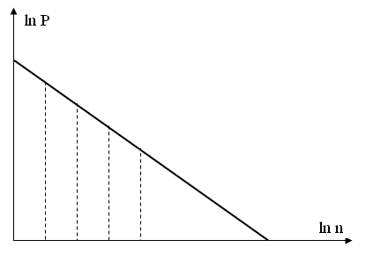
Fig. 1. Rank-size dependence

This pattern has been empirically established to be relevant for cities systems in some countries. Still, there are regions and countries where urban systems studied for rank - size relationships indicate a number of significant deviations from the original model.
This has led to a more general form of dependence which relies on a C-constant instead of P₁ in addition to the denominator of fraction being proposed to be raised to a q degree.
P_{n}=C*n (1),
where C and q are some (specific to a given country and a given period of time) constants. Naturally, this equality is understood as a theoretical model, which corresponds to empirical data approximately, in particular, for n=1, Р₁=С.
Abandoning the exact equals q=1 and С=Р₁ allows for improving the overall accuracy of the model significantly.
Even with the model as a whole being statistically reliable, each individual city may, however, significantly deviate from its calculated value. The most stark deviations are characteristic of the main city (n = 1).
With the total number of cities in the country m known, one can estimate the approximate number of the total urban population of the country P:
P = С + С/2 + С/3 +…+ С/ m = С (1 + 1/2 + 1/3 + …+ 1/m) (2)
The Zipf's law has been re-checked on numerous occasions. All of them have substantiated the over-time stability of the q parameter as well as its value as being close to 1. Further research into this pattern has made it possible to suggest existence of stability over time for this type of distribution of urban population in a country or a separate, economically independent region in cities of different rank. This hypothesis is also valid for instances of a the general population increase in each of the system of cities under examination. This has resulted in the hypothesis that the heterogeneity in the distribution of population by cities corresponds to the manifestation of market economy economic laws and is a mathematical description of the general pattern of functional division between cities. For instance, this pattern finds reflection in the Kristaller theoretical model. Apparently, main city studies should involve a set of special indicators to characterize the unique economic status of the main city and its significant superiority.
Zipf's law has been successfully used to study the system of cities in the United States and other regions and countries [2-6].
The rank size pattern was also applied to USSR cities. It was established that the Zipf's law generally corresponded quite well to the urban population distribution in the USSR in the mid-twentieth century. In particular, in 1979, the population of the largest USSR cities was as follows (in millions): Moscow - 8.01; Leningrad – 4,59; Kiev - 2.14; Tashkent – 1,78; Baku – 1,55; Kharkov – 1,44; Gorky – 1,34; Novosibirsk – 1,31; Minsk – 1,28; Kuibyshev – 1,22; Sverdlovsk – 1,21, etc. The main state entity following the collapse of the USSR at the end of 1991 was the Russian Federation. The largest cities list lost some of the capitals of the former Soviet Union republics, such as Kiev, Tashkent, Baku, Kharkov, Minsk, etc. The new ranking of Russian cities within the rebuilt economic space in the Russian Federation saw Nizhny Novgorod (Gorky) moving from the 7th place to the 4th, Novosibirsk - from the 8th to the 3rd, Samara (Kuibyshev) - from the 10th place to the 6th, Yekaterinburg (Sverdlovsk) - from the 11th to the 5th, etc.[5]. These processes which took place during the transition period (the period of collapse of the Soviet Union) translated into a significant deviation from the Zipf pattern. However, this fact is not viewed as a refutation of the rank - size law as this law can only be applied in the context of the system of cities being relatively stable within the economic space under study. It is probably safe to assume proceeding from that premise that the end of the transitional period associated with the establishment of independent economic systems in the former USSR republics will be marked by the re-established rank-size pattern in relation to the set of cities of each of the new economically independent Russian regions. This law can be checked against, from the pespective of independent economic system, the system of cities in the Republic of Tatarstan. To that end, we will put the largest cities in the Republic of Tatarstan in the order corresponding to their population (Table 1).
.
Table 1 «Rank to size» ratio
No, rank | City | Population, thousand people*
1 | Kazan | 1100
2 | Nab.Chelny | 528.5
3 | Nizhnekamsk | 212.5
4 | Almetyevsk | 148
5 | Zelenodolsk | 99
6 | Bugulma | 93
7 | Leninogorsk | 68
8 | Elabuga | 67.6
9 | Chistopol | 65
10 | Zainsk | 43
11 | Bavly | 23
12 | Buinsk | 18.5
*The population of cities is given in round numbers based on the data from the official website of the Republic of Tatarstan [7].
R is defined as the rank of a city in the system of cities in the Republic of Tatarstan while R represents the city population (in thousands). Let us calculate the mathematical dependence lnP = f (ln R) (Table 2).

Table 2 Dependence lnP = f (ln R)
ln R | 0 | 0,69 | 1,09 | 1,39 | 1,61 | 1,71 | 1,95 | 2,08 | 2,20 | 2,3 | 2,4 | 2,48
ln P | 7,0 | 6,27 | 5,36 | 4,99 | 4,60 | 4,53 | 4,22 | 4,21 | 4,17 | 3,76 | 3,13 | 2,92

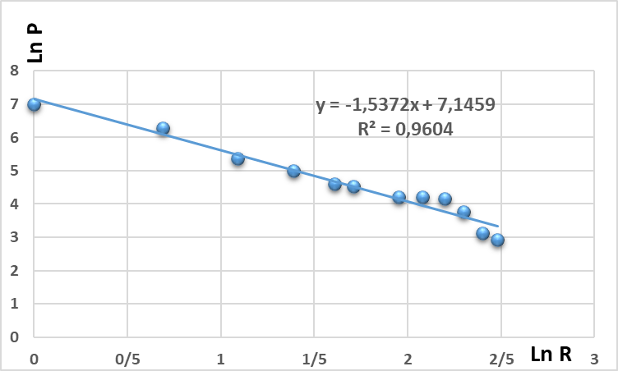
Fig. 2. The rank-size dependence calculated for cities in the Republic of Tatarstan

As is evidenced by the analysis of the diagram obtained for the system of cities in the Republic of Tatarstan, the rank size law applies quite accurately. Let us use the least square method to establish the equation of the straight line lnP = f (ln R), an approximation of the calculated data.
Results and Discussion
The equation of the line is found in the form u = ax + b. The least square coefficients a and b have values of 1,5372 and 7,1459 , respectively. In this case, the approximating line equation is
u = - 1,5362x + 7,1459 (3),
where u is LnP, x is Ln R.
The coefficient of determination (R² = 0,9604) shows a significant relationship between the studied values.
The uneven development of cities disturbs the linear dependence of the rank size pattern. This, in turn, raises the question of social injustice which results in the need to restore the proportional development of the system of cities through the implementation of the “city alignment“ state program. This can be achieved by curbing the growth of the main city, promoting the development of other cities within the system as opposed to the main city, etc. That is, offered here are ways to introduce violent changes to the previously existing rank-size ratios. For example, such attempts were made in the USSR. A case in point is that it was often decided to found new industrial centers instead of developing existing ones when choosing the location to build large plants such as VAZ (Togliatti), — VAZ, KAMAZ (Naberezhnye Chelny), GAZ (Nizhny Novgorod), etc. This has led to the emergence of predominantly monofunctional cities which are currently faced with considerable difficulties which arise from the need for functional restructuring in the new economic environment [8].
In the early 1960s, world urban policy raised the question of defining the optimal city size within the national urban system. The solution to this issue was to define the focus areas of investment programs. In particular, there was a need to choose between developing old cities or creating new ones.
The upshot of the urban policy in the 1960-70-s was no general success in identifying the right measures to achieve balanced development of regional centers. It has become evident that policies aimed at creating new cities are experiencing some difficulties [8]. When created near major cities, new cities fall under their influence and turn into "bedroom cities" with the main functional purpose being that of relieving part of the burden of the central city. If new cities are created at a considerable distance from major centers, their independent economic existence and development experience considerable difficulty.
That implies that rank-size pattern examinations go hand in hand with classical problems inherent in the economy public sector. This certain failure in the urban equalization policy in the development of the regional economic strategy indicates the need to come up with a scale of flexible approaches to solve this issue.
Acknowledgements
The work is performed according to the Russian Government Program of Competitive Growth of Kazan Federal University.
References
Gabaix, Xavier. Zipf’s Law for Cities: An Explanation. Quarterly Journal of Economics 114 (3): 739–67 (1999).
Kali R. The city as a giant component: a random graph approach to Zipf's law. – Applied Economics Letters 10: 717-720(4), 2003.
Axtell, Robert L. Zipf distribution of US firm sizes. American Association for the Advancement of Science (2001).
Zipf G.K. Human Behavior and the Principle of Least Effort. – Addison-Wesley Press, (1949).
Zanadvorov V. S., Zanadvorova A. V. The city’s economy: textbook/ V. S. Zanadvorov, – M.:Master, (1998).
Starovoitov M. K. Medvedeva L. N. Using a systematic approach to managing urban. – Economic revival of Russia. 2007. №2 (12), 39–43.
Federal service of state statistics in the Republic of Tatarstan. URL: http://tatstat.gks.ru/wps/wcm/connect/rosstat_ts/tatstat/ru/statistics/population/
Mironova M.D. Investigating the development of cities in the territory of the Russian Federation / Ekonomicheskoye vozrozhdeniye Rossii. 2010. № 1 (23), 82-88.

