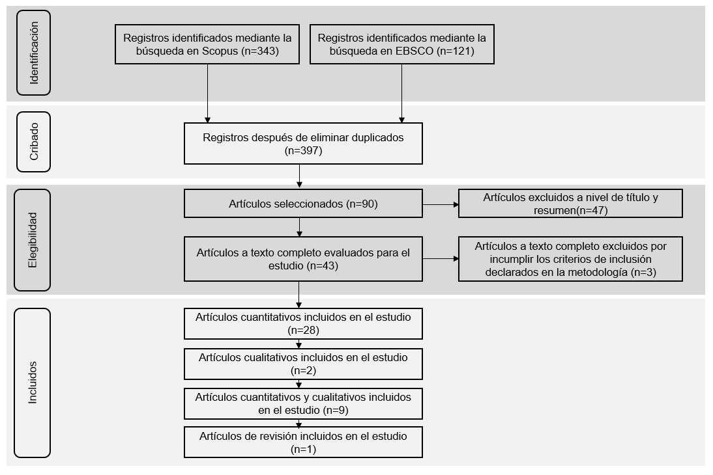
Figura1
Adaptación de PRISMA Flow Diagram

Tabla 1
Investigaciones incluidas en la revisión

N° | Autor / año / título | Datos | País | La familia y la COVID-19, efectos psicosociales
 |  |  |  | Familia | Padres | Niños | Adolescentes | Jóvenes | Abuelos
1 | Chen, S. Q., Chen, S. D., Li, X. K., & Ren, J. (2020). Mental Health of Parents of Special Needs Children in China during the COVID-19 Pandemic | SCOPUS | China |  | X
2 | Wu, Q. y Xu, Y. (2020). Parenting stress and risk of child maltreatment during the COVID-19 pandemic:A family stress theory informed perspective | SCOPUS | China | X
3 | Ivbijaro G. (2021), Psychological impact and psychosocial consequences of the COVID 19 pandemic Resilience, mental well-being, and the coronavirus pandemic | SCOPUS | UK | X
4 | Törő, K. & Csikós, G. (2020), Families Face Pandemic – A Review of Psychological Suggestions and Empirical Findings Regarding the Covid-19 Pandemic | EBSCO | Hungría | X
5 | Pereda, N. & Díaz-Faes, D. (2020)Family violence against children in the wake of COVID-19 pandemic: a review of current perspectives and risk factors | EBSCO | España | X
6 | Borghi, L. & Julia Menichetti, J. (2021), Strategies to Cope With the COVID-Related Deaths Among Family Members | EBSCO | Italia | X
7 | Prikhidko, A., Long , H. & G. Wheaton, M. (2020),The Effect of Concerns About COVID-19 on Anxiety, Stress, Parental Burnout, and Emotion Regulation: The Role of Susceptibility to Digital Emotion Contagion | EBSCO | USA |  | X
8 | Hudimova, A. (2021), Adolescents’ Involvement in Social Media: Before and During Covid-19 Pandemic. | EBSCO | Ucrania |  |  |  | X
9 | Pratiwi, H. et al (2020),Assessing the Toxic Levels in Parenting Behavior and Coping Strategies Implemented During the COVID-19 Pandemic | EBSCO | Indonesia |  | X
10 | Stoianova, T. , Ostrovska, L. & Tripulskyir, G. (2020), COVID-19: PANDEMIC OF DOMESTIC VIOLENCE | EBSCO | Ucrania | X
11 | Zhang, L. et al (2020), Effects of Irritability of the Youth on Subjective Well-Being: Mediating Effect of Coping Styles | EBSCO | China |  |  |  |  | X
12 | Yue, J.,et al (2020). Anxiety, depression and PTSD among children and their parent during 2019 novel coronavirus disease (COVID-19) outbreak in china. Current Psychology, doi:10.1007/s12144-020-01191-4 | SCOPUS | China |  |  | X
13 | Di Giorgio, E., et al (2020). The interplay between mothers’ and children behavioral and psychological factors during COVID-19: An italian study. European Child and Adolescent Psychiatry, doi:10.1007/s00787-020-01631-3 | SCOPUS | Italia |  | X
14 | Kryukova, T. L., et al (2020). Stress and coping in a self-isolated family during COVID-19 pandemic. [Стресс и совладание в семье в период самоизоляции во время пандемии COVID-19] Social Psychology and Society, 11(4), 120-134. doi:10.17759/SPS.2020110409 | SCOPUS | Rusia | X
15 | Zhang, H. (2020). The influence of the ongoing COVID-19 pandemic on family violence in china. Journal of Family Violence, doi:10.1007/s10896-020-00196-8 | SCOPUS | China | X
16 | Spinelli, M., et al (2020). Parents' stress and children's psychological problems in families facing the COVID-19 outbreak in italy. Frontiers in Psychology, 11 doi:10.3389/fpsyg.2020.01713 | SCOPUS | Italia |  | X
17 | Rajkumar, R. P. (2020). COVID-19 and mental health: A review of the existing literature. Asian Journal of Psychiatry, 52 doi:10.1016/j.ajp.2020.102066 | SCOPUS | India | X
18 | Evans, S., et al (2020). From “It has stopped our lives” to “Spending more time together has strengthened bonds”: The varied experiences of australian families during COVID-19. Frontiers in Psychology, 11 doi:10.3389/fpsyg.2020.588667 | SCOPUS | Australia | X
19 | Lebow, J. L. (2020). The challenges of COVID-19 for divorcing and post-divorce families. Family Process, 59(3), 967-973. doi:10.1111/famp.12574 | SCOPUS | USA | X
20 | Orgilés, M.,et al (2020). Immediate psychological effects of the COVID-19 quarantine in youth from italy and spain. Frontiers in Psychology, 11 doi:10.3389/fpsyg.2020.579038 | SCOPUS | Italia España |  |  | X | X
21 | Raza, S. H., Haq, W., & Sajjad, M. (2020). COVID-19: A psychosocial perspective. Frontiers in Psychology, 11 doi:10.3389/fpsyg.2020.554624 | SCOPUS | Pakistán | X
22 | Xu, Y., Wu, Q., Levkoff, S. E., & Jedwab, M. (2020). Material hardship and parenting stress among grandparent kinship providers during the COVID-19 pandemic: The mediating role of grandparents’ mental health. Child Abuse and Neglect, 110 doi:10.1016/j.chiabu.2020.104700 | SCOPUS | USA |  | X |  |  |  | X
23 | Thomeer, M. B., Yahirun, J., & Colón-López, A. (2020). How families matter for health inequality during the COVID-19 pandemic. Journal of Family Theory and Review, 12(4), 448-463. doi:10.1111/jftr.12398 | SCOPUS | USA | X
24 | Brown, S. M., et al (2020). Stress and parenting during the global COVID-19 pandemic. Child Abuse and Neglect, 110 doi:10.1016/j.chiabu.2020.104699 | SCOPUS | USA |  | X
25 | Kowal, M., et al (2020). Who is the most stressed during the COVID-19 pandemic? data from 26 countries and areas. Applied Psychology: Health and Well-being, 12(4), 946-966. doi:10.1111/aphw.12234 | SCOPUS | 26 países y áreas
26 | Mousavi, S. F. (2020). Psychological well-being, marital satisfaction, and parental burnout in iranian parents: The effect of home quarantine during COVID-19 outbreaks. Frontiers in Psychology, 11 doi:10.3389/fpsyg.2020.553880 | SCOPUS | Irán |  | X
27 | Herbert, J. S., et al (2020). Identifying rewards over difficulties buffers the impact of time in COVID-19 lockdown for parents in australia. Frontiers in Psychology, 11 doi:10.3389/fpsyg.2020.606507 | SCOPUS | Australia |  | X
28 | Brown, G., & Greenfield, P. M. (2021). Staying connected during stay-at-home: Communication with family and friends and its association with well-being. Human Behavior and Emerging Technologies, 3(1), 147-156. doi:10.1002/hbe2.246 | SCOPUS | USA | X
29 | Mazza, C., et al (2021). The COVID-19 lockdown and psychological distress among italian parents: Influence of parental role, parent personality, and child difficulties. International Journal of Psychology, doi:10.1002/ijop.12755 | SCOPUS | Italia |  | X
30 | Mantovani, S., et al (2021). Children ‘under lockdown’: Voices, experiences, and resources during and after the COVID-19 emergency. insights from a survey with children and families in the lombardy region of italy. European Early Childhood Education Research Journal, 29(1), 35-50. doi:10.1080/1350293X.2021.1872673 | SCOPUS | Italia |  |  | X
31 | Uzun, H., Karaca, N. H., & Metin, Ş. (2021). Assesment of parent-child relationship in covid-19 pandemic. Children and Youth Services Review, 120 doi:10.1016/j.childyouth.2020.105748 | SCOPUS | Turquía |  | X
32 | Ravens-Sieberer, U., et al (2021). Impact of the COVID-19 pandemic on quality of life and mental health in children and adolescents in germany. European Child and Adolescent Psychiatry, doi:10.1007/s00787-021-01726-5 | SCOPUS | Alemania |  |  | X | X
33 | Guo, J., et al (2021). Maternal mental health during the COVID-19 lockdown in china, italy, and the netherlands: A cross-validation study. Psychological Medicine, doi:10.1017/S0033291720005504 | SCOPUS | China, Italia y Paises Bajos |  | X |  |  |  | X
34 | Magson, N. R., et al (2021). Risk and protective factors for prospective changes in adolescent mental health during the COVID-19 pandemic. Journal of Youth and Adolescence, 50(1), 44-57. doi:10.1007/s10964-020-01332-9 | SCOPUS | Australia |  |  |  | X
35 | Cohodes, E. M., McCauley, S., & Gee, D. G. (2021). Parental buffering of stress in the time of COVID-19: Family-level factors May Moderate the association between pandemic-related stress and youth symptomatology. Research on Child and Adolescent Psychopathology, doi:10.1007/s10802-020-00732-6 | SCOPUS | USA | X |  |  |  | X
36 | Bradley, L., et al (2021). COVID-19: Counseling with bereaved parents. Family Journal, doi:10.1177/1066480721992510 | SCOPUS | USA |  | X
37 | Liu, Y., et al (2021). Associations between feelings/behaviors during COVID-19 pandemic lockdown and depression/anxiety after lockdown in a sample of chinese children and adolescents. Journal of Affective Disorders, 284, 98-103. doi:10.1016/j.jad.2021.02.001 | SCOPUS | China |  |  | X | X
38 | Penner, F., Hernandez Ortiz, J., & Sharp, C. (2021). Change in youth mental health during the COVID-19 pandemic in a majority Hispanic/Latinx US sample. Journal of the American Academy of Child and Adolescent Psychiatry, 60(4), 513-523. doi:10.1016/j.jaac.2020.12.027 | SCOPUS | USA |  |  |  |  | X
39 | Lorenzo, N. E., et al (2021). Transactional associations between parent and late adolescent internalizing symptoms during the COVID-19 pandemic: The moderating role of avoidant coping. Journal of Youth and Adolescence, 50(3), 459-469. doi:10.1007/s10964-020-01374-z | SCOPUS | USA |  | X
40 | Msherghi, A., Alsuyihili, A., Alsoufi, A., Ashini, A., Alkshik, Z., Alshareea, E., . . . Elhadi, M. (2021). Mental health consequences of lockdown during the COVID-19 pandemic: A cross-sectional study. Frontiers in Psychology, 12 doi:10.3389/fpsyg.2021.605279 | SCOPUS | Libia | X

