Figure 1. Distribution of sociodemographic variables (n= 118)

Table 2. Correlation Professional development
 |  | Sef-knw | Collab. | Respons. | Confid | Develop | Motiv. | Observ.
Self-knowledge | Corr. | 1 | ,126 | ,406** | ,241** | ,463** | ,336** | ,212*
 | Sig. |  | ,173 | ,000 | ,008 | ,000 | ,000 | ,021
Collaborative skills | Corr. | ,126 | 1 | ,305** | ,082 | ,295** | ,195* | ,077
 | Sig. | ,173 |  | ,001 | ,378 | ,001 | ,034 | ,410
Responsibility | Corr. | ,406** | ,305** | 1 | ,367** | ,401** | ,420** | ,281**
 | Sig. | ,000 | ,001 |  | ,000 | ,000 | ,000 | ,002
Confidence | Corr. | ,241** | ,082 | ,367** | 1 | ,122 | ,083 | ,277**
 | Sig. | ,008 | ,378 | ,000 |  | ,186 | ,374 | ,002
Development | Corr. | ,463** | ,295** | ,401** | ,122 | 1 | ,454** | ,216*
 | Sig. | ,000 | ,001 | ,000 | ,186 |  | ,000 | ,019
Motivation | Corr. | ,336** | ,195* | ,420** | ,083 | ,454** | 1 | ,358**
 | Sig. | ,000 | ,034 | ,000 | ,374 | ,000 |  | ,000
Observation | Corr. | ,212* | ,077 | ,281** | ,277** | ,216* | ,358** | 1
 | Sig. | ,021 | ,410 | ,002 | ,002 | ,019 | ,000
**. Correlation is significant at the 0.01 level (2-tailed). / *. Correlation is significant at the 0.05 level (2-tailed).

Table 3. Contingency analyses
 | Sex | TO | TE | TC | RE | D | PsL | PL | SL
Sex | - | 2,902  ,86 | 3,245  ,59 | ,121  ,029 | 3,164  -,026 | ,789  ,023 | 7,465**  -,252** | 1,659  ,118 | 4,128*  ,186*
TO | 2,902  ,86 | - | 6,642  -,077 | 2,066  ,088 | 5,497  -,126 | 7,494  -,178* | 2,458  ,098 | 1,361  ,103 | ,172  ,003
TE | 3,245  ,59 | 6,642  -,077 | - | 3,382  ,074 | 123,876**  ,174* | 9,72  ,124 | 3,388  -,081 | 6,697  -,186* | 8,596  ,208**
TC | ,121  ,029 | 2,066  ,088 | 3,382  ,074 | - | 40,644**  -,326** | 1,466  ,069 | ,121  ,029 | 3,298  ,145* | 2,951  -,138*
RE | 3,164  -,026 | 5,497  -,126 | 123,876**  ,174* | 40,644**  -,326** | - | 11,287  ,15 | 11,287  ,15 | 3,202  -,022 | 6,799  -222**
D | ,789  ,023 | 7,494  -,178* | 9,72  ,124 | 1,466  ,069 | 11,287  ,15 | - | 5,604  -126 | 23,505**  ,056 | 8,361*  -,071
PsL | 7,465**  -,252** | 2,458  ,098 | 3,388  -,081 | ,121  ,029 | 3,202  -,022 | 5,604  -126 | - | 7,105**  -,244* | 13,989**  -,343**
PL | 1,659  ,118 | 1,361  ,103 | 6,697  -,186* | 3,298  ,145* | 6,799  -222** | 23,505**  ,056 | 7,105**  -,244* | - | 23,469**  -,446**
SL | 4,128*  ,186* | ,172  ,003 | 8,596  ,208** | 2,951  -,138* | 12,599**  ,144 | 8,361*  -,071 | 13,989**  -,343** | 23,469**  -,446** | -
TO: teachers observed by peers; TE: Teaching experience; PsL: Preschool level; PL: Primary level; TC: type of centre; RE: Region of Spain; D: discipline; SL: secondary level

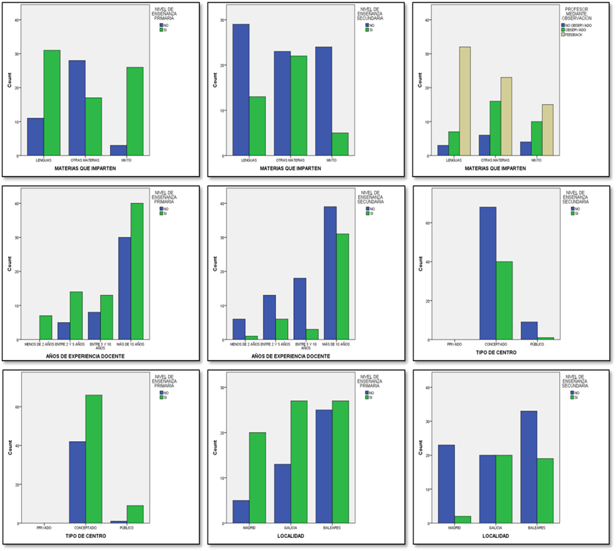
Figure 2. Significant correlations with a nonlinear relationship between variables

