Frame 1 – keywords used to search jobs on the web

PALAVRAS-CHAVE
Portuguese for foreigners
Portuguese in Brazil for foreigners
Teaching Portuguese as a foreign language
Portuguese as a foreign language
Portuguese as L2 for foreigners
Portuguese as a second language for foreigners
Source: Prepared by the authors (2020).

Table 1 - All works analyzed.

PLACE |  | THEME | NATURE | YEAR
1 | SELL Magazine – (UFTM) | TEACHING PORTUGUESE AS A FOREIGN LANGUAGE: NEW PERSPECTIVES | Article | 2014
2 | Matraga Magazine  (UERJ) | TEACHING PORTUGUESE FROM BRAZIL TO FOREIGNERS:  INTERNATIONALIZATION, CONTEXTS AND PRACTICES | Article | 2018
3 | Matraga Magazine  (UERJ) | CULTURAL, MULTICULTURAL, INTERCULTURAL:  PORTUGUESE AS A SECOND LANGUAGE FOR FOREIGNERS | Article | 2013
4 | Of the Language Museum  Portuguese (UNB) | PORTUGUESE TEACHING AS A NON-MATERNAL LANGUAGE: CONCEPTIONS AND TEACHING CONTEXTS | Article | 2005
5 | InterLetras Magazine  (Unigran) | A APRENDIZAGEM DE PORTUGUÊS COMO LÍNGUA ADICIONAL | Article | 2017
6 | Linha D’Água Magazine (USP) | LEARNING PORTUGUESE AS AN ADDITIONAL LANGUAGE | Article | 2010
7 | C @ pelo - Digital Library of TCCs  (Unesp) | REFLECTIONS ON THE TEACHING OF PORTUGUESE FOR FOREIGNERS AND ON THE TEACHING OF PORTUGUESE FOR SPEAKERS OF MATERNAL LANGUAGE | Completion of course work | 2011
8 | Digital Library of Theses and Dissertations of the Federal University of Pernambuco  (BDTD / UFPE) | PORTUGUESE TEACHING FOR FOREIGNERS: A MULTIMODAL AND MULTICULTURAL EXPERIENCE IN THE GRAMMAR NOTEBOOK VIVA IN VIVA PE | Dissertation | 2018
9 | International Publication Cataloging Data (CIP) -  Library System at UFU, MG.  Brazil | BETWEEN EXPERIENCES AND INDIVIDUALS: TEACHING PORTUGUESE TO FOREIGNERS IN THE CONTEXT OF LINGUISTIC IMMERSION | Dissertation | 2016
10 | Digital Library of Theses and Dissertations of the Federal University of Ceará  (BDTD / UFC) | THE TEACHER'S SPEECH ON THE GRAMMAR TEACHING IN PORTUGUESE CLASS AS A FOREIGN LANGUAGE | Dissertation | 2013
Source: Prepared by the authors (2020).

Quadro 2 – Os trabalhos selecionados.

PLACE |  | THEME and AUTHORS | NATURE | YEAR
1 | SELL Magazine – (UFTM) | TEACHING PORTUGUESE AS A FOREIGN LANGUAGE: NEW PERSPECTIVES | Article | 2014
2 | Matraga Magazine  (UERJ) | TEACHING PORTUGUESE FROM BRAZIL TO FOREIGNERS:  INTERNATIONALIZATION, CONTEXTS AND PRACTICES | Article | 2018
3 | Matraga Magazine  (UERJ) | CULTURAL, MULTICULTURAL, INTERCULTURAL:  PORTUGUESE AS A SECOND LANGUAGE FOR FOREIGNERS | Article | 2013
4 | Of the Language Museum  Portuguese (UNB) | PORTUGUESE TEACHING AS A NON-MATERNAL LANGUAGE: CONCEPTIONS AND TEACHING CONTEXTS | Article | 2005
7 | C @ pelo - Digital Library of TCCs  (Unesp) | REFLECTIONS ON THE TEACHING OF PORTUGUESE FOR FOREIGNERS AND ON THE TEACHING OF PORTUGUESE FOR SPEAKERS OF MATERNAL LANGUAGE | Completion of course work | 2011
9 | International Publication Cataloging Data (CIP) -  Library System at UFU, MG.  Brazil | BETWEEN EXPERIENCES AND INDIVIDUALS: TEACHING PORTUGUESE TO FOREIGNERS IN THE CONTEXT OF LINGUISTIC IMMERSION | Dissertation | 2016
Source: Prepared by the authors (2020).

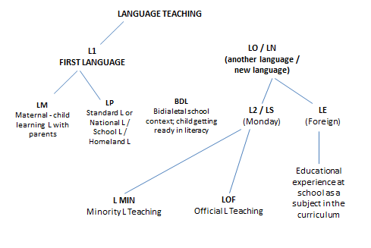
Figura 1 – Typification of teaching – learning contexts in portuguese.

Source: adapted from Almeida Filho, p.7, 2005.

